The Pennsylvania State University

The College of Information Sciences and Technology

Senior Capstone Project

SpawnPoint Final Report

Prepared by

Mario Amaro

Baba Haidara

Hunter Jones

Abstract

This literature review focuses on various applications of what will soon become the database program known as Spawnpoint. Using other literature reviews and project reports on topics such as gaming as a learning tool, the multiple uses of a database, and how to combine both technologies, Spawnpoint is a hybrid of locating nearby people who play games, no matter what kind. The author reviews these documents, going over their strengths and weaknesses in terms of how they are best integrated and how they succeed or fail at connecting to a larger audience. This in turn gives an idea as to how the authors in the group will best take advantage of the benefits to create a more connected world beyond the screens. In conclusion, the group decided to utilize the ever-evolving nature of a database as well as the expanding world of gaming to create a new way for people to connect to one another more personally.

Table of contents

Introduction 5

Problem Statement 5

Motivation 5

Objectives 5

Literature Survey 5

Literature Review 5

Assessment of available solutions and techniques 6

Pros and Cons 6

Requirement Specifications 7

Coding 7

Stakeholder Analysis 7

Market Analysis 8

Constraints 8

Assumptions 9

Risks 9

Charts 10

Operational Flow Chart 10

Technical Flow Chart 11

PERT Chart 12

Results 13

Implementation 13

Enhanced Implementation 13

Testing 13

Revision 13

Conclusions 13

Changes in Development 13

Challenges 14

Lessons Learned 14

Future Work 14

References 15

# Introduction

## Problem Statement

With people joining back into society and needing to re-establish those semi-lost/create new social connections, how do we unite people with common interests and give them a way to ease back into how things were in the world?

## Motivation

In the initial stages of this group’s formation, we realized that all members have a common interest in video games. As we are re-assimilating back to normal and socializing outdoors again, we wanted to capitalize on an opportunity the pandemic caused. The lockdown resulted in an increase in video game users and with our application, these users will have access to a wide database of games, easy communication with friends, and the option to meet with local players as a social tool.

## Objectives

Completion of this project will result in increased social interaction between people both online and offline. As the project will implement a free signup feature, we are expecting a bare minimum of 1,000 new members to sign up for the app within the span of two weeks after the app goes live, taking advantage of the app’s abundance of connections.

# Literature Survey

## Literature Review

The COVID-19 pandemic has had a major impact on mental health throughout the world. It has caused grief, social anxiety, depression, and even suicide. But some of the ways we have coped with our isolation has been with the increase in social technology such as meeting applications (ZOOM, Facebook, Google etc.) and entertainment through streaming services and video games. Video games allow us to both socialize and be entertained, but it wasn't for everyone. Now more people are turning to video games of all ages to help themselves through isolation. Our research is looking into data on how the isolation from the pandemic affected mental health and how video games assisted with the mental health issues by providing entertainment and socialization. We will also be looking into how video games can be used as a learning tool and a way to relieve stress or anxiety. Our solution is going to be creating an application that will allow game players to search for other players who are playing the same game or invite other players to join a game they are playing on a variety of consoles, personal computers (PC), or board games and it also offers a way for them to communicate. This application will also show if there are other players in their local area. This project is going to be a social tool for people who are looking to socialize in a COVID-19 pandemic that requires us to isolate and for people who are looking for like-minded game players.

## Assessment of available solutions and techniques

The ability to socialize while playing games is nothing new. The oldest method being couch games, where you would meet up with friends and play games in a single home. The most recent method is through communication apps such as discord, through video game consoles that allow you create a ‘party’ or through the game itself such as call of duty. Some players already have their group or team of friends meet to join in chat. Others rely on meeting with someone while playing the game.

## Pros and Cons

Pros and Cons of existing approach

* Couch Gaming
  + Pros
    - Familiar with the people you know
    - Communication is easy
    - The best way to socialize
  + Cons
    - Requires planning a physical meetup
    - Not good during a pandemic
* Communication App
  + Pros
    - Easy way to talk to others
    - Can send invites
  + Cons
    - You have to have already planned to be in the chat for the game.
* Console or video game communication
  + Pros
    - Built in
    - Lets you create chat groups with people who have a similar console
    - Notifies if other friends are playing the same game(only on the same console)
  + Cons
    - Your team either already needs to be created
    - You are randomly put in group

# Requirement Specifications

Coding

The application was developed using Python 3.10 and Django. The database is SQLite and the WebSocket char server is Redis.

## Stakeholder Analysis

|  |  |  |  |
| --- | --- | --- | --- |
| **Stakeholder** | **Power** | **Interest** | **Legitimacy** |
| Video Game Users | High | Low | Low |
| Game Development Companies (Nintendo, Activision, Ubisoft, Sega, …) | Low | High | High |
| Video games retailers (Best Buy, GameStop, PlayStation Network, Steam, …) | Low | High | High |
| Console Manufacturers (Nintendo, Microsoft, Sony, …) | Low | Low | High |
| Video Game Investors | Low | High | Low |
| Production Team (Developers, Investors, and Company owners) | High | High | High |

SpawnPoint has six stakeholders’ worth considering at each phase during the project life cycle. Each has their own reason for being a stakeholder and based on these reasons we can rank them on how invested they are in this project. Our top stakeholder is the production team which consists of the developers, investors, and owners of the company. With high power, interest and legitimacy, this stakeholder is tasked with managing the project closely as they are the most invested in all aspects of the project. Game development companies and the retailers tasked with selling the games have low power and high interest meaning they should be kept informed on the project. Additionally, they have high legitimacy as they stand to gain in profits and revenue if this project goes well. This application can be used to gather data and help game development companies and retailers. This is what distinguishes them from video game investors, console manufacturers and video game users. These three remaining stakeholders, while less of a priority, are still important for the success of the project. The users have low interest and legitimacy because they have alternatives, but they are the main audience this project is aiming to satisfy making them have high power in what goes into this application. Video game investors have low power and legitimacy since they have other options and this project failing will not affect their investments but if it succeeds and is able to help advertise games profiting the companies they invest in, then they would benefit explaining the high interest. And lastly, the console manufacturers have low power and interest as they have alternatives of their own in place and any actions by them would not change the objective of this project. However, they do have high legitimacy as they would be a suitor to buy this application and use it as their main form of gaming communication.

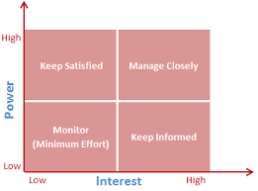

## Market Analysis

The gaming industry is one that has continued to grow and has been an active part of so many people’s daily lives and for some this has been the case their entire life. According to Accenture Analysis, there was an estimated 2.7 billion gamers worldwide during 2021, 405 million subscribers on YouTube to the top 10 gaming influencers, and the direct and indirect value of the gaming industry is estimated to be more than $300 billion, which is much higher than previous estimates (Accenture, 2021). With figures like these, the field of gaming is quite popular, and it is only growing creating ample room for new applications such as Spawnpoint. This application is more than your basic online messaging and chatting app, it allows you and encourages you to socialize with others in your area with similar interests. Because the pandemic caused the world to isolate, and everything has become virtual including schools. This has created an issue with younger kids who are missing out on learning valuable social skills but with the use of this app, these kids will be able to communicate and work together gaining those skills in a new world we need to adapt to, especially with technology continuously growing. According to the Response for Teens blog, which serves to help teens with daily mental and physical problems, “77% of boys play online video games with friends at least once a month.” (Fishman, 2022). This only further supports the idea that there is an audience for such an application that allows individuals to find others to play games, both video and board, with the possibility of gaining friends.

## Constraints

For this project, there are a few concerns that can come up during the project’s life cycle. These concerns are manageable and with proper risk management in place, we should be able to overcome the risk by identifying it as early as possible, assessing it, then treating the risk and monitoring it even after it has been treated. The constraints we are facing for this project include the deadline of the project (end of semester), virtual workspace, API access restrictions, and data security as we do not want to be giving people’s exact location away as this can be unethical and lead to possible dangers. Therefore, we will have to work on a way to provide people with players in their area of similar interest while keeping the users' information safe. Additionally, this public application can draw out unethical or obscene behavior and it is our responsibility to ensure that this is used in the safest and most ethical way possible and create a safe space for those looking to socialize and play their favorite games with others. Our goal is to help people socialize and one way people can do this through our application is to play with people and have physical meetups and hangouts. So it is not only up to the users to make sure the other individuals are safe to meet with, but also up to us to secure user data to prevent theft as well as scams. There are other applications we can integrate to help boost security and protection for the users, like Tinder does using Moonlight to verify the users is who they claim to be, avoiding catfish and other serious issues that these socializing apps face. Again, these constraints are quite manageable and with proper communication, collaboration, and research, the project will go smoothly. Lastly, board games themselves are losing popularity since technology and video games specifically are growing and drawing kids’ attention away from board games. However, this application will aim to promote both video and board games and attempt to overcome this constraint.

## Assumptions

In the creation of this project, there is an assumption that video games and board games will continue to grow, especially virtually as the pandemic showed the world how much can still operate while being virtual. Furthermore, this project assumes that other similar applications will not add similar key features SpawnPoint has that separates it from its competitors. In addition, there will be an assumption that this platform is more socio-emotional rather than task-oriented. This assumption is based on the statistics from a study done in 2006 showing that out of 5800 messages sent online while playing games, socio-emotional messages were 3.2 times more likely to be sent compared to task-oriented ones. And of the emotion-based messages, they were 2.6 times more likely to be positive than negative (Fishman, 2022). And lastly there is an assumption that peoples’ intentions are not malicious, and that this platform will be used for those who either want more friends in general or find a group of people to play games with consistently and possibly competitively.

## Risks

Notable risks that the team is aware of and focusing to mitigate is the project’s own local area player searching tool, which could be used for nefarious purposes as much as it can be used beneficially, such as hacking their personal information or breaking into the area uninvited.

# Charts

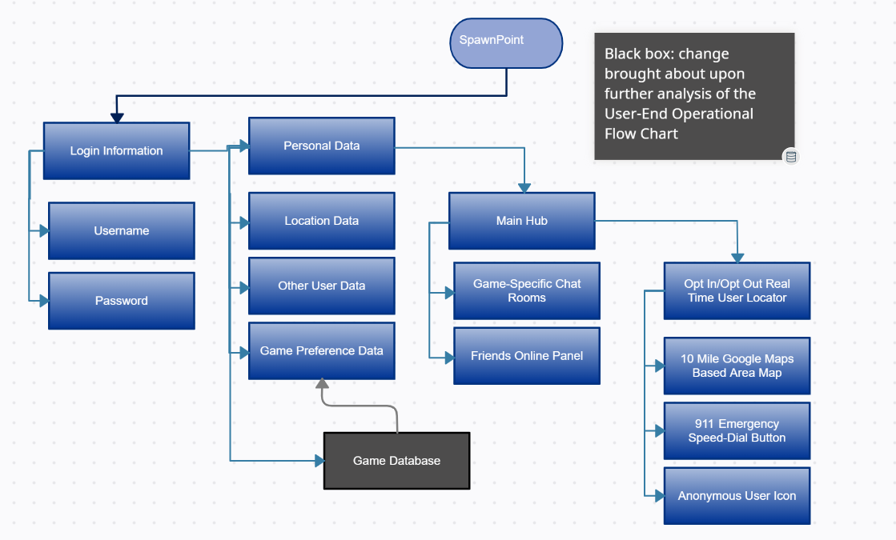

Operational Flow Chart

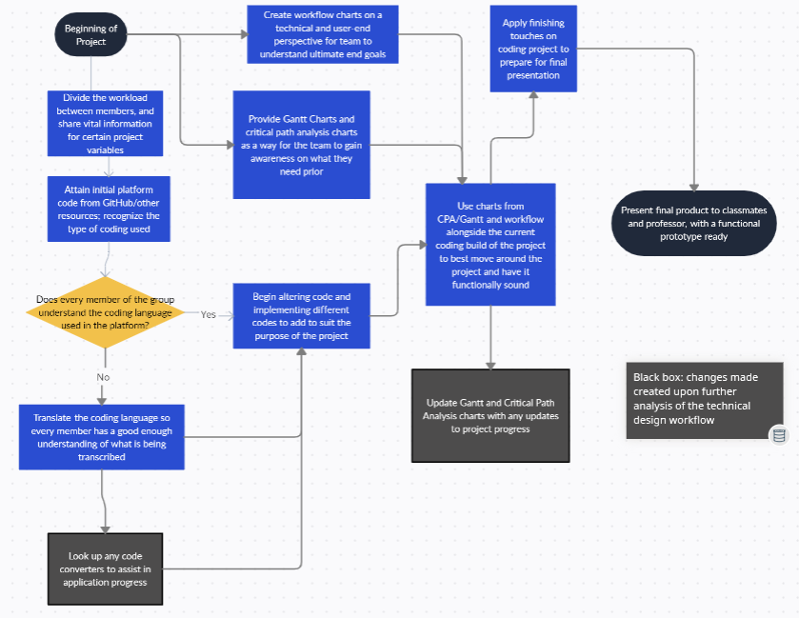

## Technical Flow Chart

# Results

## Implementation

During the implementation phase we took an existing social media repository written in python and changed the format to make it what we need for the gaming application. We also gathered two other repositories to for a database already compiled of games and a map API.

## Enhanced Implementation

During the enhanced implementation we changed the code of the social media repository to match the theme of our platform and gave it a change in color scheme that added an individualized touch. During this phase there were issues applying the API to the program, messaging, and CSS/JavaScript issues.

The code was written in Phyton Django and required several updates to match the current phyton version. This caused issues with calling CSS to the front matter but was mostly resolved. There were still issues with JavaScript lines that were not being called in.

The program also requires a WebSocket for the messaging feature to work. The WebSocket needs to be established and maintained for the messaging to go across between two members. Getting the WebSocket started is trickier than it sounds and requires constant monitoring to make sure it does not crash.

Implantation of the map API is a struggle. Still researching code to get each user to their own map to view other members in their local area to view games.

## Testing

The application will rely on a server to operate. Without the server the application will not load, and no one will be able to access anything. This attack was just shutting off the server

To solve this issue, we are going to need a backup server in case of a crash. Our product is going to use google cloud services and we will have a backup server ready in case of a crash.

We are estimating having from 4k-5k users. Our main concern is having slow load times or server crashes because we underestimated the number of users at launch.

So, to help alleviate the issue by expecting the unexpected and having more users we will purchase more space than is needed. Once the platform stables out, we will adjust memory as needed to save cost.

## Revision

The application was revised to accommodate for the servers not crashing at launch in the case of a user overload. Also, we updated our google cloud services to have more server space and a backup server.

# Conclusions

## Changes in Development

Our development process did change throughout the semester. We originally wanted to do an application in Java but due to our limited skills we chose to do something in Python because it was closer to HTML and CSS. Another thing was getting a server to run the social network platform so that everyone can see it. We wanted to use google maps, but it was challenging getting the API to function. We still have not landed on a good API to work with what we want it to do. We also changed the color scheme from the original mockup to have a better flow when visiting the website.

## Challenges

As stated in our results we did run into several challenges for the application. Our most significant problems were lack of skill in coding and time. All of us had little amounts of coding and this became a challenge when going through other repositories and finding something that was close enough to our skill level. With our beginner skill levels time became our enemy. We had to research many things to get even close to what we wanted out of our application. We bit off a little more than we could chew, and we struggled with time. There was also a map feature and messaging feature that we struggled with because of lack of skill. Both will be refined over time.

## Lessons Learned

Communication management was a big lesson learned in this project. There were several tasks that could have been easily resolved if there was better communication within the group.

Time Management was also important in our project. Doing research for better project management software would have helped us with time. Also, communication was a flaw in our time management.

Skill Level was important because we had several tasks that were beyond our skill level. We should have done more research and picked up a project that was more associated with our skill level. Possibly having someone who has a more fitting skillset when it comes to coding. This would have made part of the implementation much easier.

# Future Work

Throughout this project, we faced many challenges that allowed us to grow in various aspects. Given the time constraint of this project, we were unable to explore various options we had intended to that aimed at adding unique features and providing a better service for the users. These features include

* Larger Server
* Bigger Database
* More clear connections to emergency services
* More anonymous settings if chosen
* More filters to increase personalization

That being said, this project overall has given us insight into potentially working on this project far beyond our tenure at Penn State. Consequently, due to the lack of well-known competition, should we choose to continue development of this application outside of school time we may move to publish it live to the world and monetize it as well. If any buyers are interested in the project and decide to buy it, they would have a good infrastructure allowing the transition of the project with minimal issues and errors.

GITHUB Link  
https://github.com/Maa6131/Spawnpoint

References

Accenture. “The New Face of Gaming.” *Accenture*, 27 Apr. 2021, <https://www.accenture.com/us-en/insights/software-platforms/gaming-the-next-super-platform>.

Fishman, Andrew. “Video Games Are Social Spaces: How Video Games Help People Connect.” *Video Games Are Social Spaces: How Video Games Help People Connect | ResponseCenter*, 2022, <https://www.jcfs.org/response/blog/video-games-are-social-spaces-how-video-games-help-people-connect>.

“Stakeholder Analysis Using the Power Interest Grid.” Edited by Yaman Bdaiwi, *Project Management*, 24 Mar. 2017, <https://www.projectmanagement.com/contentPages/wiki.cfm?ID=368897&thisPageURL=/wikis/368897/Stakeholder-Analysis--using-the-Power-Interest-Grid>.